**ABSTRACT**

The Vehicle Log Management System for SGS is system used to automate the Vehicle Log Book where all details including trips record, fuel, battery, repair among others are

Recorded on a daily basis .

The Vehicle Log Management System for SGS was developed using Spiral model in order to establish a system which aims to solve the problems that currently exists within their company. Using our proposed system, the process of capturing vehicle records will become faster and more accurate, more efficient and reliable way in creating Vehicle report ..

This proposed system is solving the problems that the company is facing by using manual capturing of data through implementing a system that acknowledges speed and accuracy over the inefficient and time consuming manual system that the business is currently using.

This project proposed is built to minimize the error and to improve the functionality of the system for the convenience and to support the organization’s objective.

Proposed Modules :

* Record of journey
* Record of battery
* Record of Tyre
* Record of Fuel
* Record of Repairs /Service
* With driver login and Admin/Supervisor
* Incidents/Occurence
* Record of Tools
* Vehicle Particulars.

Driver Loign/Functions

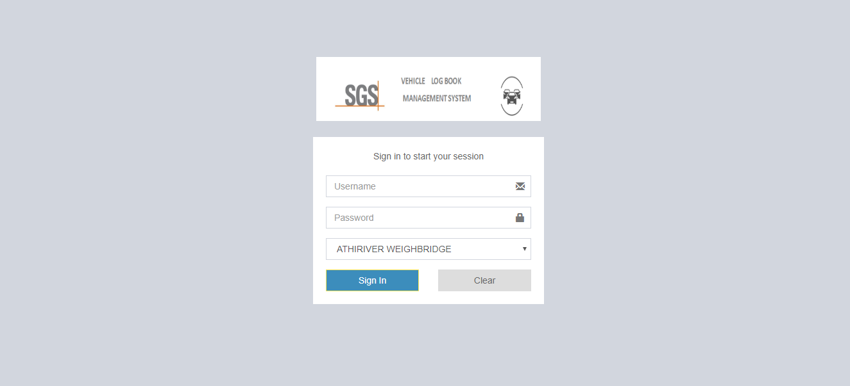

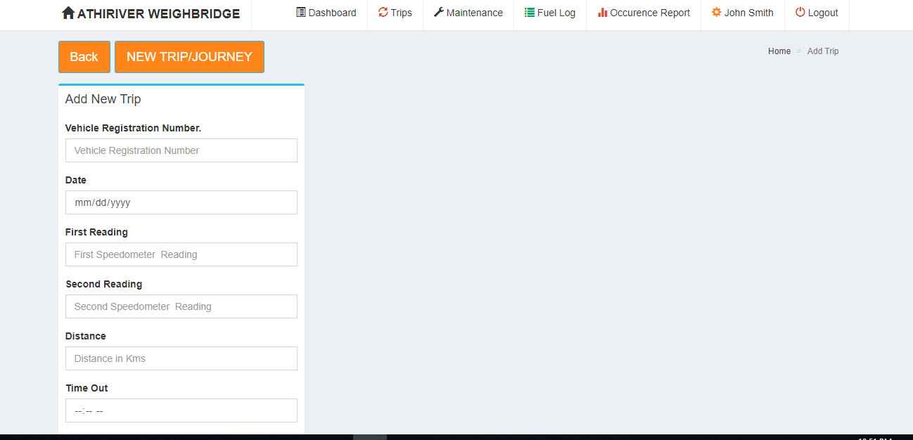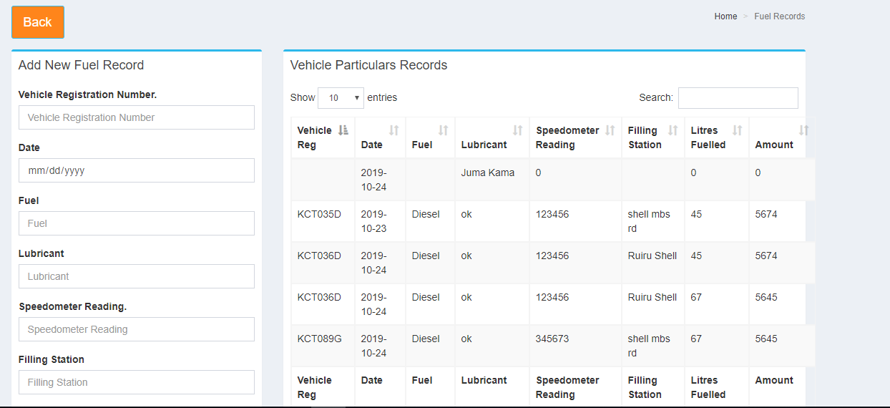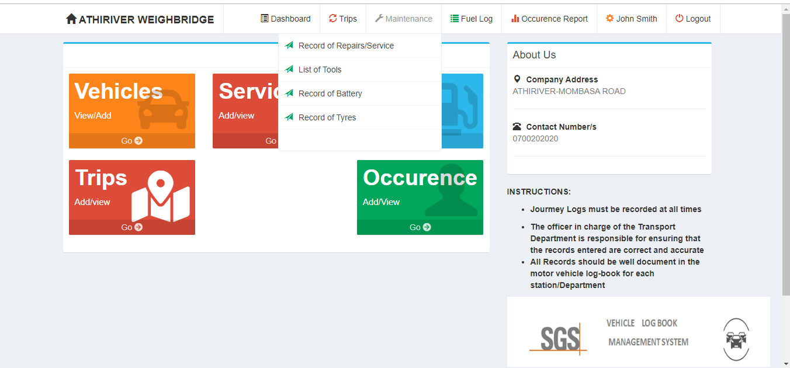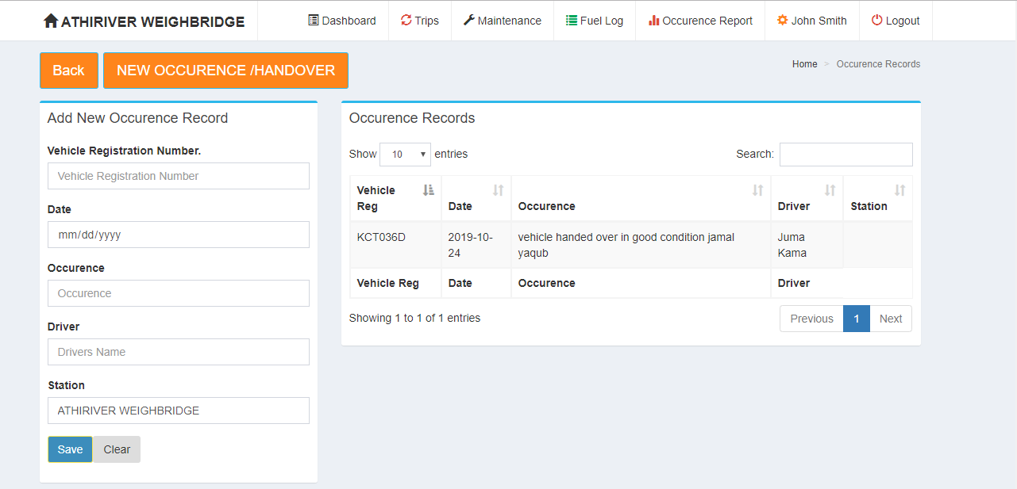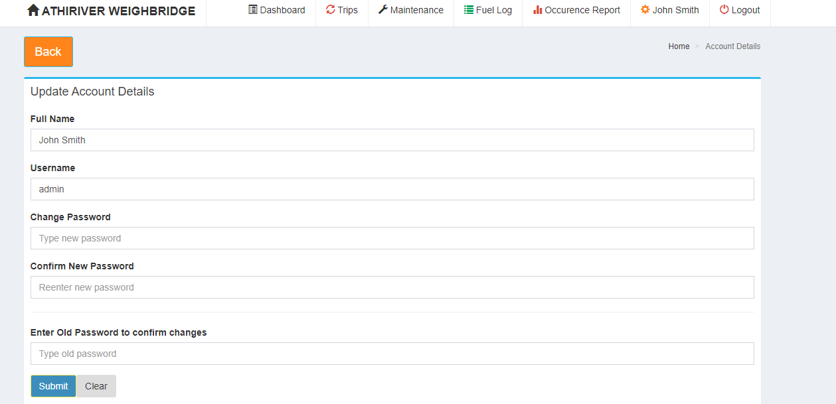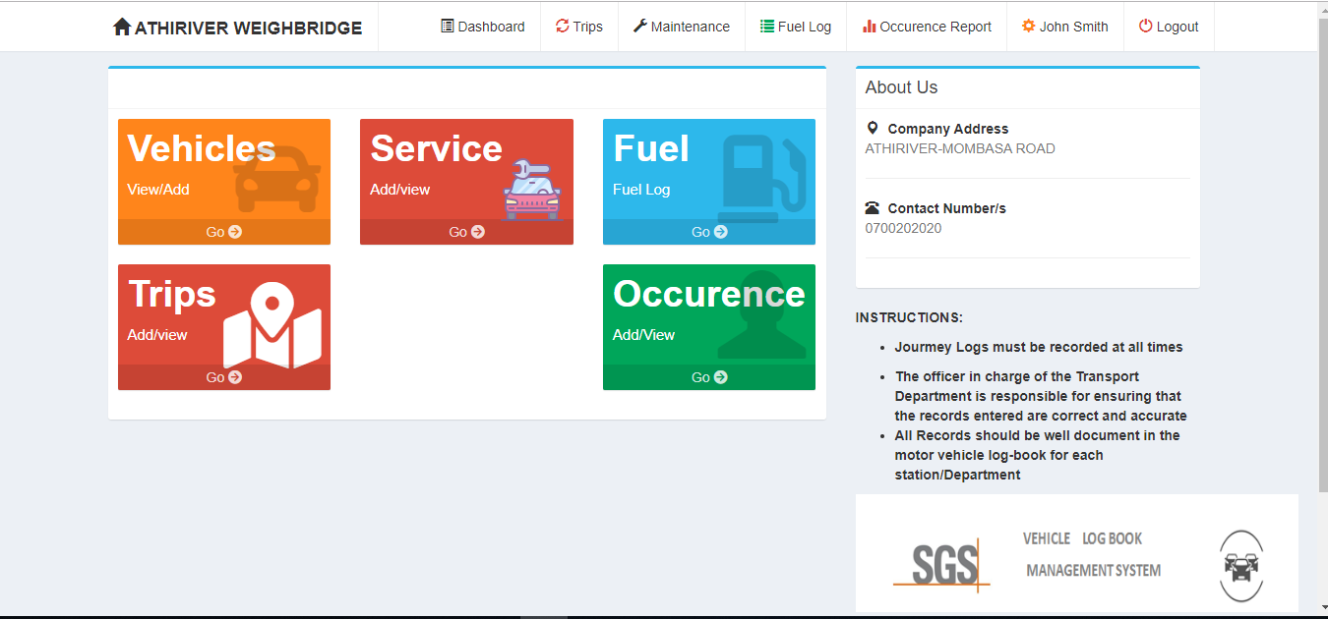

Admin/Supervisor Functions:

